HOLIDAY CALENDAR
Client Reference :
URL : https://drauat.elitehrms.com
User Name : 0066
Password : M@ster

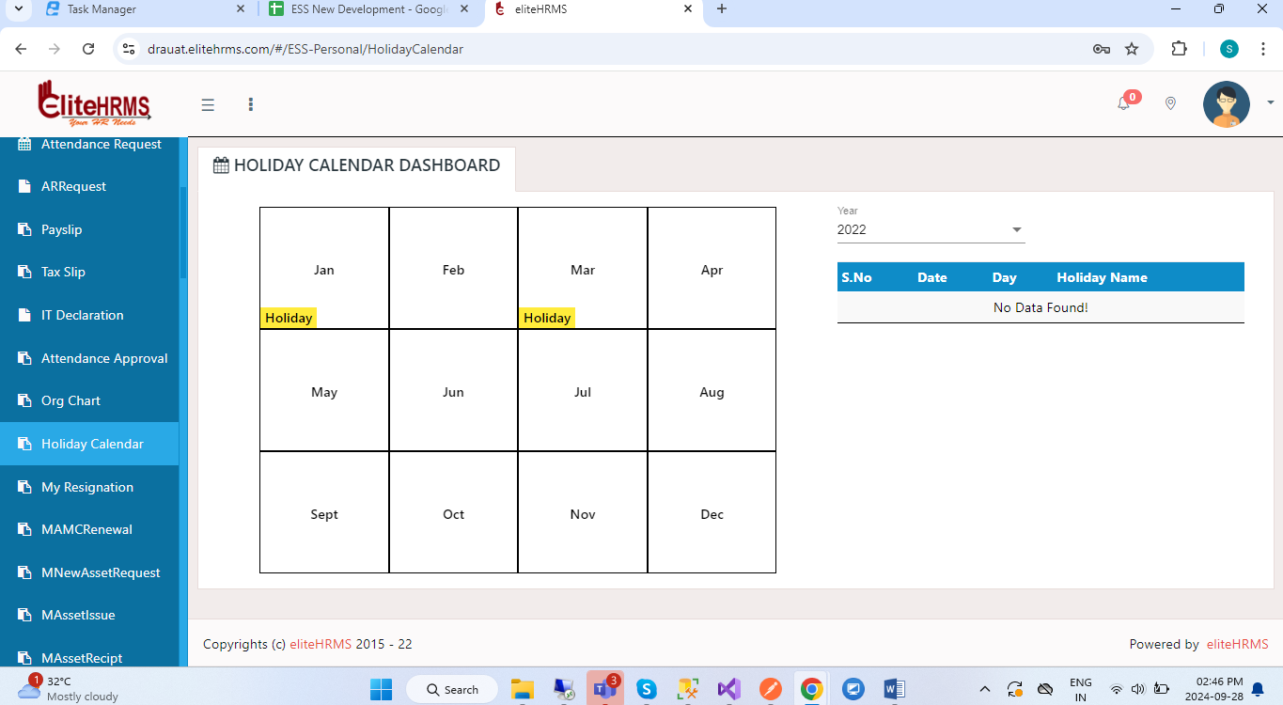
1.Don’t use this screen, screen fllow is fully changed.
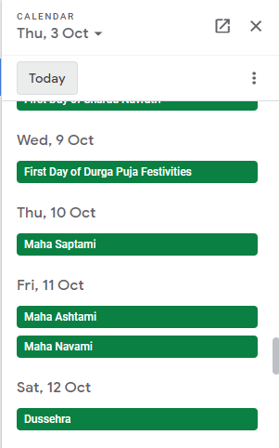

2.screen design need to change based on google calendar.
Initial Call Get Api: (default pass the Current year then month & day is non mandatory) (year will pass “yyyy” (ex : 2024))
https://localhost:44349/api/Personal/GetHolidaylist?Year=2024&Month=&Day=
{
"Response": {
"_status": "Success",
"_code": "111",
"_Source": "GetHolidaylist",
"_Description": "Log Details ...",
"_Details": "",
"_TransID": null,
"_Timestamp": "20240928145217"
},
"HolidayList": [
{
"HolidayListGUID": "0baa1f96-3019-6dd1-14bb-b503b48ec66d",
"Date": "28/09/2024",
"Day": "Saturday",
"Holidayname": "Test"
}
]
}

(Year is mandatory for all time then month only passing json)
(year will pass in “yyyy” (ex : 2024) and month will pass only number (ex : September means 09))
https://localhost:44349/api/Personal/GetHolidaylist?Year=2024&Month=5&Day=
{
"Response": {
"_status": "Success",
"_code": "111",
"_Source": "GetHolidaylist",
"_Description": "Log Details ...",
"_Details": "",
"_TransID": null,
"_Timestamp": "20240928145427"
},
"HolidayList": [
{
"HolidayListGUID": "efe1b9ce-5799-892b-d2a7-f1029d6cc020",
"Date": "01/05/2024",
"Day": "Wednesday",
"Holidayname": "May DAY"
}
]
}

(date have passing year & Month have mandatory)
(year will pass in “yyyy” (ex : 2024), month will pass only number (ex : September means 09) & date will pass only number (ex : ’28-09-2024’ means 28))

https://localhost:44349/api/Personal/GetHolidaylist?Year=2024&Month=9&Day=28
{
"Response": {
"_status": "Success",
"_code": "111",
"_Source": "GetHolidaylist",
"_Description": "Log Details ...",
"_Details": "",
"_TransID": null,
"_Timestamp": "20240928145903"
},
"HolidayList": [
{
"HolidayListGUID": "0baa1f96-3019-6dd1-14bb-b503b48ec66d",
"Date": "28/09/2024",
"Day": "Saturday",
"Holidayname": "Test"
}
]
}

